CHAPTER ONE INTRODUCTION
The emergence of early antivirus software back in the 1980s sparked the birth of a new industry where early developers of third-party antivirus solutions such as McAfee and Norton first emerged as pioneers of the commercial antivirus industry. The “Brain” computer virus in 1986 which was the first computer virus targeted at IBM PCs pushed the development of anti-virus software to combat these threats (Echegu & Agwu, 2024).
The creation and widespread usage of the World Wide Web in the 1990s directly led to the emergence of more sophisticated viruses when compared to their predecessors. During this era, the creation of Macro viruses targeted computer software such as Microsoft Word to infect and spread via email attachment and caused significant damage by overwhelming email servers (Nilupul, 2024). As a countermeasure, antivirus companies such as McAfee and Norton constantly pushed updates to protect their users against any dangerous viruses and became synonymous with basic computer protection especially for home and business users. This made third-party antivirus software a household name and cemented their reputation for protecting everyday users from cyber threats.
As malware continue to evolve and threaten everyday users with increasingly advanced threats beyond traditional exploits and viruses, it is no wonder that third party antiviruses have managed to maintain their reputation. The study by Ferdous (2023) highlighted a sharp rise in ransomware, cryptojacking and fileless malware which operates entirely in RAM alongside attacks targetting mobile devices, IoT networks and remote workers. This rise in increasingly dangerous cyber-attacks means users have to be weary of their devices being hijacked, performance degradation and in the worst case scenario data theft and financial loss all without visible signs. With the most popular method of attack being phishing, everyday users are at risk of exposing themselves to these threats during their daily browsing.
However, as operating systems continue to develop, so do their built-in security services and protection features, for example, Microsoft Defender. With modern operating systems such as

Windows 11 offering a solid and capable built-in antivirus solution, the question arises whether there is still a need to purchase and invest in third-party antivirus solutions (Delaney, 2020). Despite Microsoft Defender’s evolution as a reliable antivirus solution, Cruz (2024) reported that over 121 million adults rely on third-party antivirus software. Americans aged 65 or older were twice as likely to pay for antivirus services compared to those under 45. While over half of users stick with system default antivirus or none at all, nearly half still rely on third-party solutions which indicates a continued belief in their added value. Of those who use third-party antivirus, 54% pay for the service, with 84% of users citing general security against malware and viruses as their primary reason for using third-party antivirus.
With built-in antivirus like Microsoft Defender improving significantly over the years, many users face a dilemma: is investing in third-party antivirus software still worthwhile, or is the default protection provided by the system now sufficient? This project aims to compare and evaluate the performance, detection, and usability of built-in antivirus solutions and third-party antivirus software in Windows 10 and 11 environments. This will be done by reviewing the functionality of several major third-party antivirus solutions and Microsoft Defender. The results provided from this project will determine whether there is value in using third-party antivirus software by comparing both antivirus solutions’ performance and responsiveness to simulated threats. The project involves developing a lightweight computer software program that uses a standardized test to simulate malware detection capabilities of a third-party antivirus by measuring system performance during the detection process and comparing it against Microsoft Defender as the benchmark to determine whether the average user still benefits from third-party antivirus tools or if Microsoft Defender now provides sufficient protection by default for everyday users.

Background of Study

Microsoft Defender formerly known as Microsoft AntiSpyware was first released on October 24, 2006 and was launched as an anti-spyware tool for Windows XP and Windows Server 2003. Over time, it was developed into a full-fledged antivirus program and was completely implemented as Windows operating system built-in antivirus with Windows 8. It aimed to provide features such as real-time protection against malware and spyware as well as other known software that can potentially damage the operating system (Shinder, Diogenes, & Shinder, 2013).

On the other hand, third-party antivirus software has been offering real-time protection, prevention, performance enhancement, and safeguarding of data as early since its inception in the 1980s. Combined with the industry’s commitment of updating regularly to address new security issues, introduce new features, correct bugs and so on makes owning and paying for a third-party antivirus software more enticing (Echegu & Agwu, 2024). These offerings of new features often claim superior malware detection capabilities, smarter threat intelligence and customization features that go beyond what built-in antivirus solutions typically provide.
Despite that, in a report by Cruz (2024) 40% of Americans specifically opt to use system default antivirus with the reasoning of not needing a third-party antivirus. Paired with the fact that 54% of Americans use system default antivirus, this shows a strong trust in the capabilities of the built-in antivirus in defending their system to the point where they do not feel the need to explore and try out a third-party antivirus.
While third-party antivirus software does offer advanced and up to date security features such as McAfee Total Protection providing anti-phishing capabilities and Norton Antivirus offering features such as identity theft protection, some users view these additions as unnecessary or excessive. The he constant updates, complex interface, and bloatware that comes with the software makes it a hassle for users who rarely encounter security threats in their daily usage.
Moreover, concerns around data privacy and pricing have caused further skepticism. Cruz (2024) reported that many non-users to have security concerns regarding the misuse of customer data as evidenced by Avast deceptive practices in collecting and selling detailed user browsing data to third parties. On top of that the high price point of third-party antivirus software sits at the top of the reason as to why users do not use antivirus software. These factors acts as a significant barrier for casual users who may or may not need the additional features.
Therefore, based on the differences and user preferences, it can also be said that it is essential to evaluate antivirus software based on three core aspects, performance, detection and usability. Performance refers to how efficiently the antivirus runs in the background of the system and its impact on the performance of system processes and resource usage. Detection is the software’s ability to accurately identify and respond to various types of malware while also minimizing false positives. Usability covers on how intuitive and user-friendly the software is which includes its interface design, notification handling, ease of navigation and setup process. These three core

aspects directly impact the overall effectiveness and usability of an antivirus solution especially for everyday users who prioritize smooth system performance, reliable protection and a hassle- free user experience.
By objectively comparing antiviruses performance based on system performance, malware detection accuracy and overall usability by using a lightweight and easy-to-use evaluation tool, it enables users to make informed and factual decisions based on their antivirus needs whether it be a user seeking to evaluate their current antivirus or a family member assisting their family members.

Problem Statement

As third-party antivirus solutions continue to develop and compete with an increasingly improved built-in antivirus solution such as Microsoft Defender, there remains uncertainty about which option offers more protection, efficiency and usability for the everyday user. While the study conducted by Baker (2018) measured the impact of third-party antivirus software on the system performance compared to Microsoft Defender, the study did not test detection rates, virus scanning speed and malware removal capabilities which is an aspect this project focuses on.
Most home users rely on marketing claims or the popularity of third-party antivirus solutions leading to unnecessary spending, reduced system performance and a false sense of security especially if the software has features that the user may not even need.
While advanced benchmarking and antivirus testing platforms do exist, they are often intended for industrial experts. There should be a lightweight, user-friendly software with the purpose of assisting users in determining whether or not their antivirus is good enough for their day to day usage. The software should be backed by reliable tests conducted in a safe environment to give the benchmark tool credibility in its comparison.

Project Aim

This project aims to answer the following questions.

PQ1: Are third-party antivirus solutions better in terms of detection performance, system impact, and usability compared to built-in antivirus like Microsoft Defender for everyday users?
PQ2: Are third-party antivirus solutions still relevant or necessary for the average user in 2025, given the improvements in default operating system security?

PQ3: Can a reliable dataset of antivirus performance against standardized threat simulations be created to support objective benchmarking and comparison?
PQ3: Can a lightweight, user-friendly benchmarking tool be developed to help users make informed decisions by objectively comparing antivirus performance and detection responsiveness?

Project Objectives

This project aims to achieve the following objectives.

PO1: To determine the difference in detection performance, system impact and usability of third- party antivirus solutions compared to Microsoft Defender in a Windows 11 environment.
PO2: To determine the relevance and necessity of owning a third-party antivirus solution in 2025.

PO3: To develop an automated tool that tests antivirus performance against standardized threat simulations in a closed environment and compiles the results into a dataset for benchmarking purposes.
PO4: To develop a lightweight and simple antivirus benchmarking tool to assist users in making informed decisions on the performance of their antivirus.

Project Scope

This project will provide a comprehensive analysis of built- in vs third-party antivirus software for everyday users. The report will cover antivirus technologies and types with the intention to clearly understand how different antiviruses differ in their detection techniques. This includes the features of several major third-party antivirus solutions and Microsoft Defender. Other areas of focus in this report will be performance indicators of antivirus software, benchmarking and comparative analysis methodologies and the limitations and challenges in assessing antivirus solutions and its security effectiveness.
The project will only cover commercial antivirus products aimed for everyday users and not cover enterprise or server-level antivirus platforms. This project will also only focus on the Windows 11 operating system and not evaluate other platforms such as mobile platforms, Linux and macOS.
The lightweight benchmark tool will only run on 11. Its purpose is to automatically detect the current antivirus used by the system and compare it with results stored inside the tool. The user

will be presented with a GUI that compares all available antivirus with parameters such as detection rate, average detection time, CPU usage, memory usage and a total score out of 100. This dataset will be collected via a separate program developed to test the antivirus capabilities against standardized threat simulations in a closed environment.
The data collection tool will be developed in python to automatically run PowerShell commands in a safe environment to test the antivirus capabilities in real time and generate a report in the form of a .txt file. This report will then be compiled with all other tested antiviruses and become the dataset for the benchmark tool.
The data collection tool includes using PowerShell commands to generate an EICAR file to ensure the antivirus is working as intended first. Once the antivirus has been confirmed to be working, the tool will use PowerShell commands to run Atomic Red Team tests which will be bundled together with the tool to ensure it works in an offline environment. The tool will then measure tests detected, detection rate, average detection time, average CPU usage, average RAM usage and produce an overall score using the weighted scoring method. The tool will then store all information measured into a .txt file.
The data collection tool will only be used on a controlled safe environment which is a windows 11 virtual machine using Hyper V.

Target Audience

This project is targeted towards the following audience.

TA1: Everyday Windows users who want to understand the effectiveness of their antivirus software without technical expertise.
TA2: Tech-savvy family members or caregivers who assist less experienced users, such as older adults, in making informed decisions about antivirus protection.
TA3: Windows users aged 18 to 40 who are interested in assessing the need for third-party antivirus solutions versus built-in protection.

Project Justification

This project aims to clearly compare third-party antivirus solutions with the built-in antivirus solutions packaged together with the Windows 11 operating system. By doing so, it allows users to make informed decisions regarding their usage of antiviruses. This project aims to inform users on how well their antivirus works by conducting a comparative analysis of third-party antivirus software against built-in, supported by a purpose-built software tool designed to measure the performance of each antivirus in a controlled environment.
The significance of this project lies in its purpose to address and determine whether investing in a third-party antivirus software is necessary for users who are either thinking of using a third-party antivirus software or is currently using one. Whether it be to save cost or to simply get rid of annoying bloatware, this project aims to inform users of the capabilities of their current antivirus when compared to others on the market. With many users relying on marketing claims or assumptions, there is a critical need for a data driven project into the real-world effectiveness and impact of these antivirus solutions.
The project contributes to the field by developing two separate software that appeal to both enthusiast and casual users of computers. The data collection tool is an automated antivirus performance tester which measures the antivirus capability to deal with standardized threat simulations while the benchmark tool is a straightforward easy to use software that anyone can launch on their windows 11 operating system to measure their currently in use antivirus solutions against other antiviruses based on a carefully measured dataset collected by the data collection tool.
The project dives deep into the performance and usability of current available antivirus solutions and further explores these aspects through the development of a dedicated benchmarking tool and data collection tool.

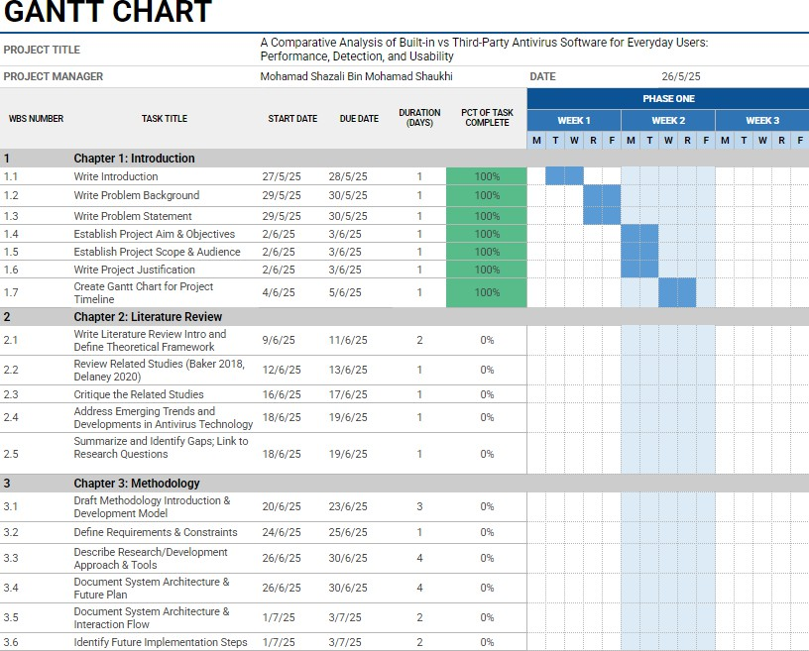
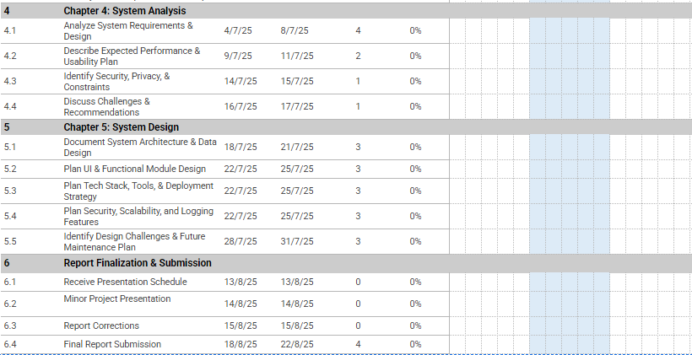
Project Timeline

